**AmberSoft Training Institute**

Sport Event Management

By

Vishwajit Aher

Under The Guidance of

Mr. Pawan Sir.

**Overview :-**

Sports Event Management is a process of organizing a sporting events, often held over multiple days, featuring competition in many different sports between organized teams of athletes from (mostly) nation-states. It involves Olympic Games, FIFA World Cup, Cricket World Cup, Super Bowl, etc. Sports Event Management is a World wide across, growing rapidly, with sports events hosted regularly. Surprisingly, there is no formalized research conducted to access the growth of this site. On the Sport Event Organizing Ambersoft Training Institute 3 profession side, event management is a glamorous and exciting profession that demands a lot of hard work and dynamism. The logistics side of the industry is paid less than the sales/sponsorship side, though some may say that these are two different industries.

**Objective :-**

The main objective of this project is to develop general purpose software for Event Management mainly to computerize the managing process. The proposed software will reduce the paper work as well as manual labour of the Company .

**System User :**

There are mainly 3 types of event management:

1.Corporate Event Management

2.Product Launch Event Management

3.Special Event Management

**EVENT MANAGER**

The Sport Event Manager is the person who plans and executes the sports. Event managers and their teams are often behind-the-scenes running the event. Event managers may also be involved in more than just the planning and Training Institute execution of the event, but also brand building, marketing and communication strategy. The event manager is an expert at the creative, technical and logistical elements that help an event succeed. This includes event design, audiovisual production, scriptwriting, logistics, budgeting, negotiation and, of course, client service. It is a multidimensional profession.

**EVENT MANAGEMENT PROCESS**

There are 2 stages of event management process namely, Event planning and Event control.

Event Planning: To plan an event we must consider the following areas of an event proposal.

Event Control: To control an event we must look on the following areas logistics, negotiations, costing & cash flow, event manual, I.T, decision making and change, risk management.

**Software Requirements:-**

**IDE/Text Editor-**

* Visual Studio Code / Sublime Text

**Front End-**

* HTML5
* CSS3
* Bootstrap5.

**Browser –**

* Google Chrome
* Mozilla Firefox.

**Scope Of The Project -**

The objective of this application is to develop a system that effectively manages all the data related to the various events that take place in an organization. The purpose is to maintain a centralized database of all event related information. The goal is to support various functions and processes necessary to manage the data efficiently.

**Use Case Diagram :-**

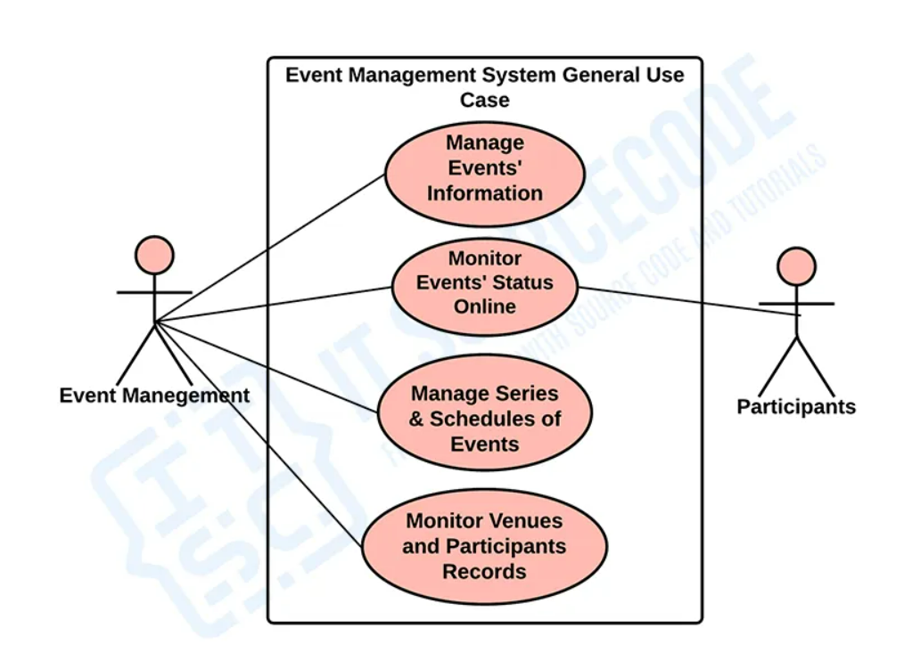

**Conclusion:-**

It has been a great pleasure for me to work on this exciting and challenging project. This project proved good for me as it provided practical knowledge of not only programming in Front-end and Back-end web based application and no some extent Windows Application and SQL Server, but also about all handling procedure related with “Sport Event Management”. It also provides knowledge about the latest technology used in developing web enabled application and client server technology that will be great demand in future. This will provide better opportunities and guidance in future in developing projects independently.